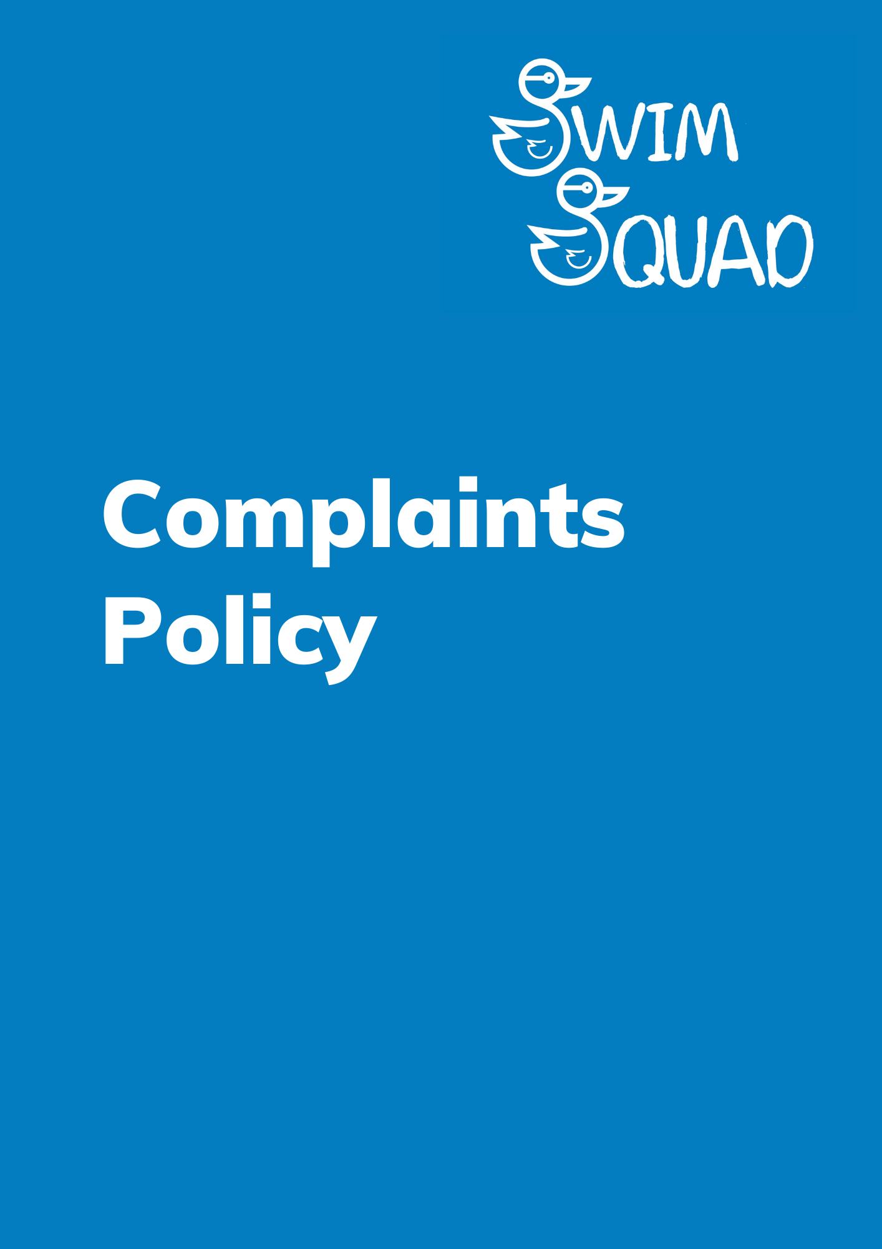
Introduction
At Swim Squad, we are committed to deliver the highest level of service across all aspects of our business. However, we acknowledge that occasional setbacks may occur, or you may find yourself dissatisfied with the service you've received. We perceive complaints as valuable opportunities for growth and improvement, both for our future endeavours and to rectify any issues for the individual or organization raising the concern. Your feedback is invaluable, and we are dedicated to making things right when things don't go as planned.
We aim to ensure that:
- The complaints procedure is an easy process to follow, being prompt and efficient.
- All complaints are treated as a dissatisfaction with our level of service.
- The correct resolution is to the complainant’s satisfaction (explanation, apology, action taken), being courteous, consultative, and responsive.
- Complaints and feedback are reviewed in line with our quality assurance standards to help improve our service, whilst being open and informative relating to the outcome.
Everyone has the right to raise a complaint, so this policy will define the stages and procedures you would need to follow, guidance is as follows:
- The process you need to follow to raise a complaint.
- The appropriate person who this should be directed to.
- The timescales for the complaint to be investigated.
- How and when you will be notified of the outcome.

Raising Concerns and Making Complaints.
All individuals can access the information about our complaints procedures through our website or can request a copy by contacting Swim Squad. We are committed to providing an equal opportunity for all, where possible, to communicate with us.
A complaint can be raised by an individual, a group, or a third party representing someone else. If a third party is submitting a complaint on behalf of another individual, they must provide written permission from the complainant, along with the written complaint attached. This documentation should then be submitted to Swim Squad for our acceptance and further processing.
Upon receipt of a complaint, Swim Squad will promptly send an acknowledgment within 7 working days. Subsequently, the complaint will undergo a thorough review in accordance with our established policies and procedures. When deemed necessary, an investigation will be initiated.

To ensure a fair and comprehensive process, the duration of the investigation will be contingent upon the nature and severity of the complaint received or the complexity of the response needed. Our objective is to provide the outcome as soon as it becomes available, with a commitment to doing so within a maximum timeframe of 28 days.

How to Make a Complaint

Stage 1:

Informal Process with Swim Squad

We understand that most individuals who are not satisfied with a service would like it addressed and dealt with as soon as possible, therefore an informal process would be far more appropriate.

An informal process will be more efficient, the appropriate manager will aim to resolve any complaints quickly by mediating between who is responsible for the dissatisfaction and the complainant. The complaint may be resolved immediately following this process, so we encourage our customers to contact us directly for an informal discussion if they have a complaint that needs to be resolved to achieve the desirable outcome.

If a complaint cannot be resolved informally then the formal complaints procedure should be followed. We may require further information from the complainant to ensure we fully understand what the complaint entails, we will investigate accordingly to achieve the best outcome. Written complaints should be sent to Swim Squad by email at admin@swimsquad.co.uk.

Verbal complaints should be made by phone on 07846 122394, or in person to any Swim Squad member of staff. In the first instance, contact Swim Squad and speak to the member of staff who is working with you, or if you feel unable, ask to speak to the Owner who will try to resolve the complaint.

If you make contact in person or by phone, make a note of the name of the person you speak to. If a solution is offered at this point, please make a note of this as well.

What Happens Next?

You may be contacted to make sure that we have understood your complaint properly.

If, as a consequence of your complaint, disciplinary actions are initiated against a member of our team, our internal procedures will be invoked. You will receive notification that disciplinary proceedings have been initiated. However, please be aware that these proceedings are conducted with a strict emphasis on confidentiality.

While we will inform you that disciplinary actions have been taken, we can only share details or outcomes of matters that fall outside the scope of this confidential procedure. Your understanding of this confidentiality is greatly appreciated as we work diligently to address your concerns and uphold our commitment to a fair and just resolution process.

If a criminal offence is alleged, then the police will be informed.

Formal Process with the Swimming Teachers Association (STA)

If the complainant is not satisfied with the outcome from the informal process a complaint should be submitted in writing to our governing body Swimming Teachers Association (STA):

Complaints Department
The Swimming Teachers’ Association
Anchor House
Birch Street
Walsall
WS2 8HZ
United Kingdom

It is strongly advised that complaints are sent to STA via recorded post. Once they have received a formal complaint in writing they will send acknowledgement of receipt to the complainant within 7 working days and an investigation to resolve the dissatisfaction will commence.

The Swimming Teachers’ Association will identify an appropriate senior manager to review the complaint for further investigation and the complainant will be notified of the individual responsible for this. The member of management will conduct a further investigation into the complaint, upon completion of the investigation they will communicate and notify the complainant and provide them with an explanation or resolution.

To ensure a fair and thorough process is followed throughout the investigation will depend on the nature and severity of the complaint we receive at this stage, or the complexity of the response required. The STA aim to provide this as soon as the outcome is available, however in some instances this may take longer to conclude the complaint with an outcome, therefore the complainant will be notified of revised timescales.

Stage 2:
Appeal Process
If the complainant is not satisfied with the outcome from the stage 1 complaints process, you have 14 days to submit an appeal to The Swimming Teachers’ Association. The appeal must be in writing, including all relevant information for the grounds of the appeal.
If The Swimming Teachers’ Association accept the appeal the complainant shall receive acknowledgement within 7 working days that the complaint has reached the appeal stage.
The appeal committee, consisting of Trustees, will be notified and will meet within 14 working days to address the complaint.
The evidence below will be forwarded to the Appeal Committee:
- All information regarding the complaint
- Evidence from stage 1
- Any other relevant documentation/information.

The Appeal Committee will meet to discuss and take one of the following actions:
- Uphold the initial decision.
- Uphold the appeal.
- Request further information from the complainant.
- Request one or all that are involved to attend an interview.
- Take any other appropriate course of action were deemed necessary.
The complainant and all involved shall be notified of the decision, in writing, as soon as it is available or within a maximum of 28 days of the final decision.

Record Keeping
Information relating to complaints are kept on file for the following duration:
- Complaints which are closed: Information deleted immediately.
- Complaints which are upheld: Information kept on file for five years.

Monitoring and Review
This policy and its accompanying procedures will undergo an annual review, as mandated by our quality assurance standards, to ensure its continued relevance, alignment with the types of appeals we may encounter, and adherence to the processes stipulated by our qualification regulators.
The next date for review will be September 2024

